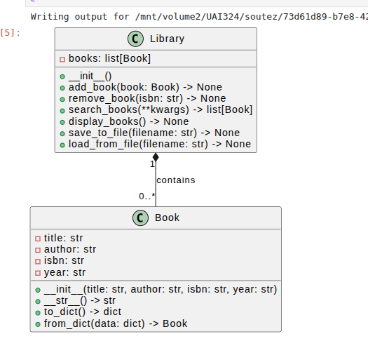
Example BII - UAI 324 (advanced)

Exam – practical part – winter 2025/26

Name of student
Date

The simple library – use OOP (preferable)

Create a Python program that simulates a simple library management system. The system should allow users to:
- Add new books to the library.
- Remove books from the library.
- Search for books by title, author, or ISBN.
- Display all books in the library.
- Save the library's state to a file and load it back.

Explanation:
- Book Class: Represents a book with attributes like title, author, ISBN, and year. It includes methods to convert the book to a dictionary and vice versa for serialization.
- Library Class: Manages a collection of books with methods to add, remove, search, display, save, and load books.
- Main Function: Provides a menu-driven interface for users to interact with the library system.
- File Handling: Uses JSON to save and load the library's state to/from a file.

Key Concepts Covered:
- Object-oriented programming (classes, objects, methods)
- Data structures (lists, dictionaries)
- File handling (reading/writing JSON files)
- User input and menu-driven interface
- Searching and filtering data
Input:
Output: store into Moodle
- your_program – name the program with your name

